Video 1 – Introduction
Videos 2 Recap of Week 3
Last week we created an sql file, Films.sql and used the SQLite engine to use the script in this file to create a database called Films.db. This database contains a table called Films which has 3 fields, FlmID, Title and Year and is populated with records about James Bond movies.
We added code to the FilmDetails project file which allows us to connect to the database. The code was a reference to the Microsoft Entity Framework Sqlite namespace and the version.
We created an Entities file which creates a class Film with properties which match the fields in the table Films in the database.
We also created a Context file which specifies what dataset we want to extract. Each item in that dataset has a Film type (ie. FilmID, Title and Year). The options builder specifies the database name and type that we want to connect to which the SQLite database we created called Films.db.
One we established the connection and setup the Entities and Context file we added code in Program file which:
- Creates an instance of the FilmsDatabase class, defined in the Context file, where we connect to the Films database
- Get a dataset from the Films table and convert the data into a list and assign the list to a variable called films.
- Use a foreach loop to go through each single film in Films list and display the properties of it.

Video 3 – Making Changes to a Database Table
Before we start new examples, you should create a folder called Week04 and copy the contents of Week03 into it. So, you should have the FilmDetails folder and its contents and the database sql and db files.
We want to change the content of Films.sql to include another field called ActorID. You can modify the contents of Films.sql as follows:
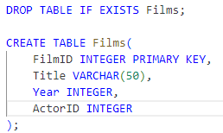
This code adds the field ActorID as an integer type.
You can modify it further as follows:
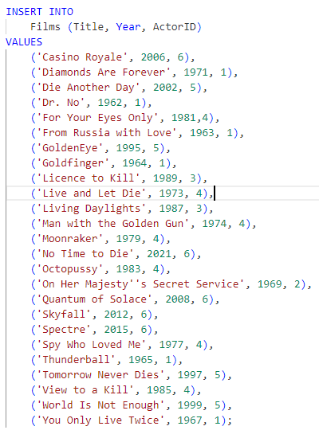
This code adds a value at the end of each record, ranging from 1 to 6, for this new field.
We want to recreate this new database using the same code as in week 3:
Type .exit to exit the sqlite prompt.
You can open the database in SQLiteStudio to check that you can see the additional field and data in the records.

Video 4 – Displaying Those Changes
Now that we have added an extra field we want to display it. This is straightforward as we have done this already. Add the following code in the Entities file after the Year property:

Modify the code within the foreach loop in the Program.cs:
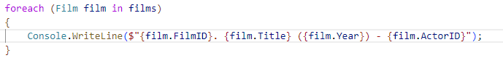
This will now display the Actor who played James Bond in each of the movies.
Build and run the application and you should see the film ID, title, year and actor ID.

Video 5 – Adding a Table to a Database
So far, we have worked on a flat database which means it only has one table. Normally a database would have multiple tables and relationships between them so that an application can extract data from multiple tables.
So we want to repeat the same process and add a new table and add data to it. Add the following code to the Films.sql file:
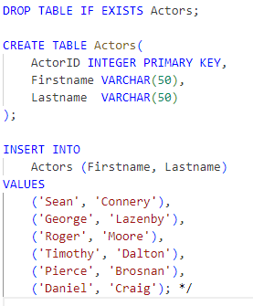
This code creates a new table with 3 fields, ActorID, Firstname and Lastname. ActorID is an integer and a primary key so it will be set automatically by the database using auto increment, so we don’t need to add values for the data. It is not by accident that ActorID is the same name and type as in the Films table. This will allow us to join these tables together and create a relationship.

Video 6 – Opening the Database in SQLite Studio
Recreate the database again and open the database to check that you can see the additional table. Check the structure and the data.

Video 7 – Creating New Entity Classes
Before we can display data from the Actors table in the application, we need to modify the Entities file as follows:
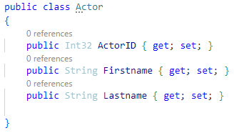
This code adds a new class called Actor with 3 properties.
If we were using additional tables, then we would need to add a new class for each one with properties which match the attributes of the table.

Video 8 – Creating New Data Sets
We also need to edit the Context file as follows:
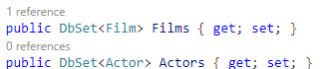
This code creates a dataset of type Actor called Actors in the same way as Film. So once we connect to the database, we can access the Actors table.
Build and run to check that there are no errors.

Video 9 – Displaying Multiple Tables
Now that we have created a class for Actors and created a dataset for it in the Context file we can add code in the Program to display content from the Actors table in the Films database. Add the following code:
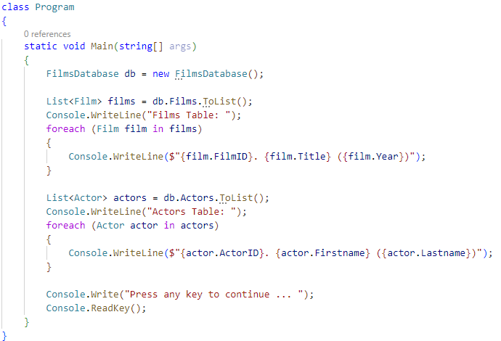
You can copy the code for Films and edit it for Actors. Build and run and data from both tables should be displayed, one below the other. It would work the same way if there were many more tables by adding similar code in Context, Entities and the application program file.

Video 10 – Creating a Class for Joining Tables
The previous example displayed the information from the tables separately. If you are familiar with databases, it is common practice to use inner join statements to join two tables together using a common field. This creates a relationship between the tables which means that you can display information from more than one table at the same time.
When you are working with C# and SQLite, you can use the same functionality by using Linq (Language Integrated Query). So anything you can do with a database in sql, you can do with Linq in C#.
We will use Linq to join the information in the Films and Actors tables using the common field ActorID. So we should have FilmID, Title, Year, Actor ID, Firstname and Lastname. So we need to create a class that will specify all of the information that a returned record will have from joining these two tables together.
Add the following code:
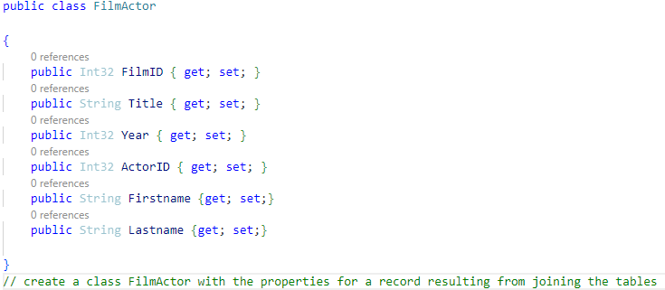

Video 11 – Joining Tables
Now we need to use this class to perform the join operation. Add the following code:
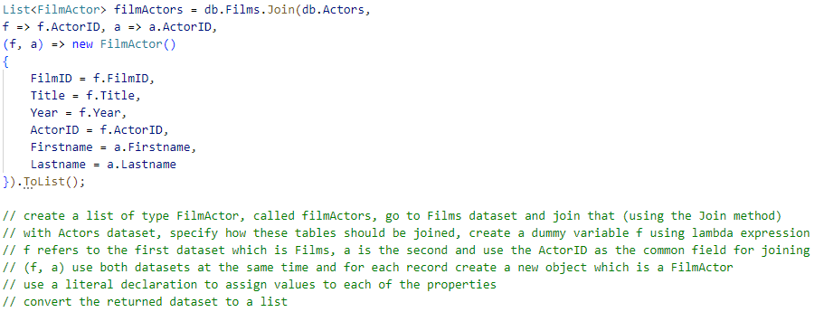
The code might appear more complex than normal but hopefully the comments will help to break it down.
Build and run to check that there are no errors.

Video 12 – Displaying the Information from Joined Tables
The records are now joined so we can display the data from both tables together using similar code as before:
Build and run the application to display the data from the joined tables.

This example shows the code over two lines to avoid using scroll bars.
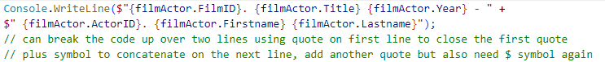

Video 13 – Ordering Records
By default, the records will be displayed in the order they appear in the database. Sometimes you may wish to display the information in a particular order. Modify the code as follows:
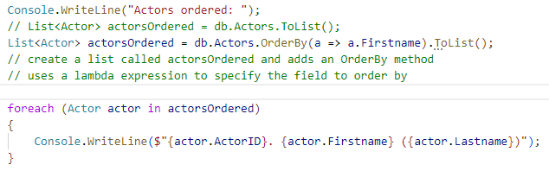
Build and run the application and the actors should be displayed alphabetically by firstname.
Change the method to OrderByDescending to display the records in descending order.

Video 14 – Selecting Information
You may wish to display some and not all of the information from the dataset.
Copy and paste the code for creating a list of films:
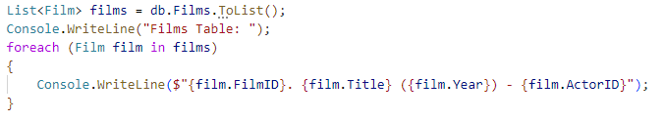
Edit the code as follows:
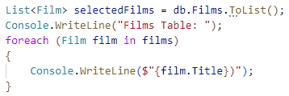
This creates a new list and displays only the film title.
But we have extracted everything from the entire table and holding it all in the Films dataset, even although we are not using it so this takes up more memory which is inefficient. Ideally, we should only extract the information that we want to use, and we can do this by using the Select method as follows:
Instead of using the list from the dataset to display the film title only, we can use it to create a list of strings which means it is less resource heavy. This can be significant when you have a large volume of records, and it can make a difference between the application running and crashing.
Edit the code as follows:
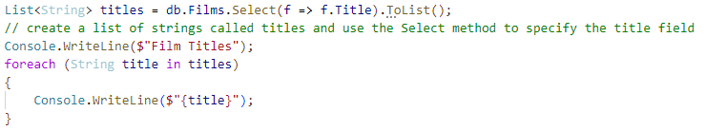
Since we only want the title we create a list of type String and apply the Select method to get only what we want, rather than using the list from the dataset. We use the lambda expression as before to get the film title from the Film dataset
Build and run the application.

Video 15 – Filtering Information
You can also filter information from a database based on criteria. Copy the code and modify as follows:
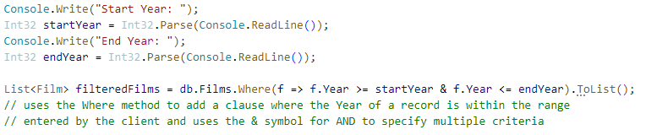
This example filters the records based on films with a particular year within a range entered by the client. It uses a Boolean operator for multiple conditions.
Finally, to display the filtered information we can add the code as follows:
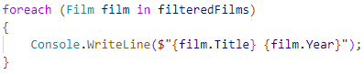

Video 16 – Running the Final Application
Run the final application from Windows Explorer. If there are any errors, copy the database file within the FilmDetails folder to the bin subfolder that contains the executable file.

